Another Roadmap School - Africa Cluster
Events and Activities to August 2017

The following web pages contain links to written, visual and moving image documentation.

SDC Working Groups:

Johannesburg
http://colivre.net/johannesburg
http://colivre.net/another-roadmap/news/khulu-skenjani-reads-prof-keorapetse-kgositsiless-1983-culture-and-resistance-in-south-africa

Lubumbashi
http://colivre.net/lubumbashi-working-group
http://colivre.net/lubumbashi-working-group/blog/lubumbashi-working-group
http://colivre.net/lubumbashi-working-group/blog/replay-1970

Maseru
http://colivre.net/maseru
http://colivre.net/africa-cluster/blog/language-literacy-as-an-agent-for-creativityarts-education.-phase-2

Another Roadmap Africa Cluster Facebook Page
https://www.facebook.com/anotherroadmapafricacluster/

July 2015
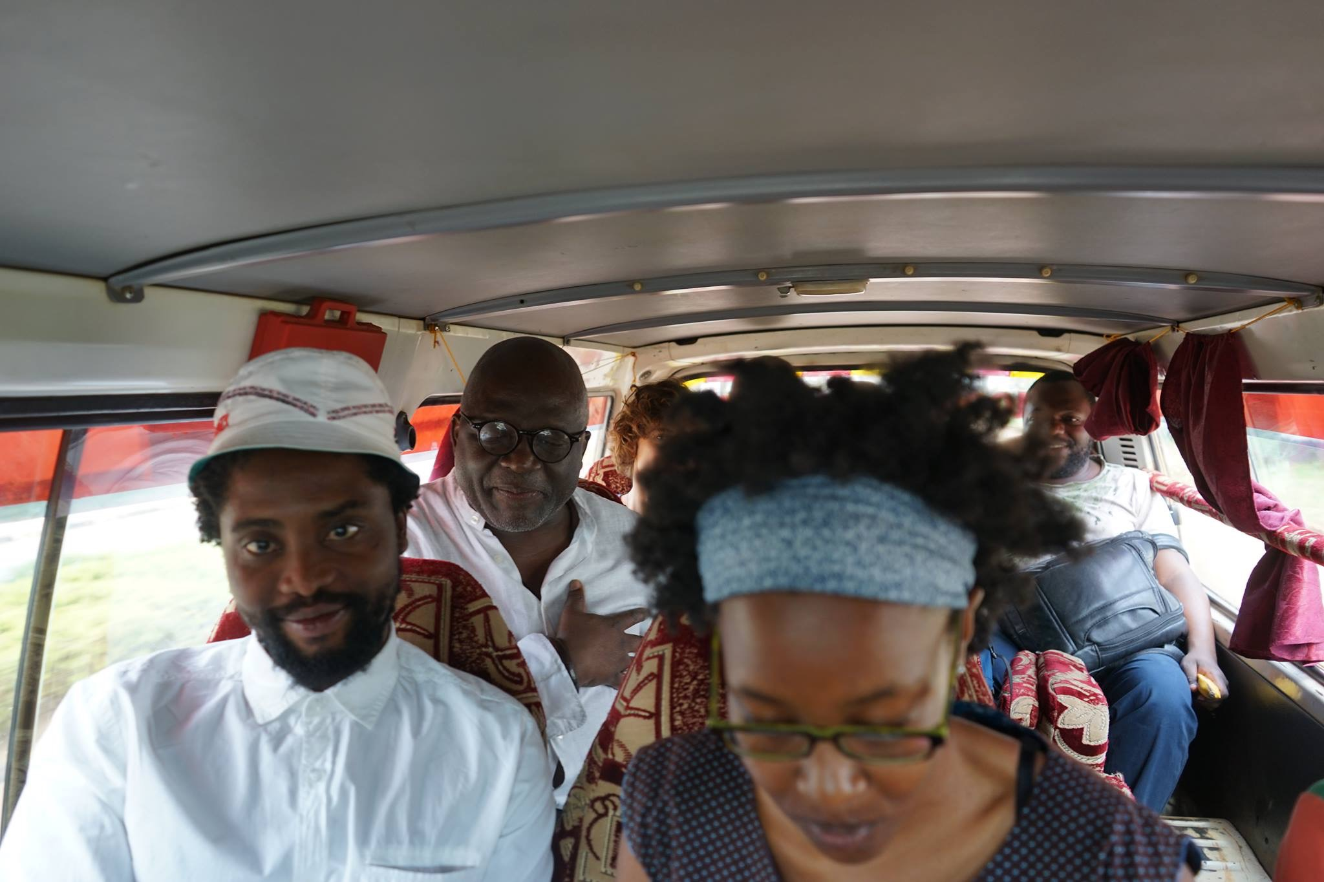
Inaugural Meeting hosted by the Nagenda International Academy of Art & Design, Namulanda, Uganda
Photo: Christian Nyampeta, 2015

http://colivre.net/africa-cluster/blog/another-roadmap-africa-cluster
http://colivre.net/africa-cluster/blog/inaugural-meeting-of-the-another-roadmap-africa-cluster

October 2015
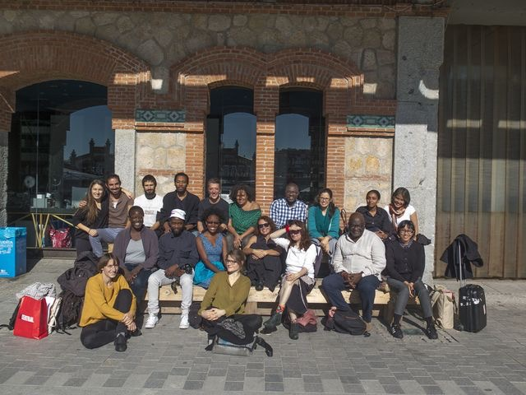
The first international meeting of the Another Roadmap School in Madrid, Spain
http://colivre.net/africa-cluster/blog/public-presentations-in-madrid (VIDEO)
http://colivre.net/another-roadmap/news/international-meeting-in-madrid

October 2016
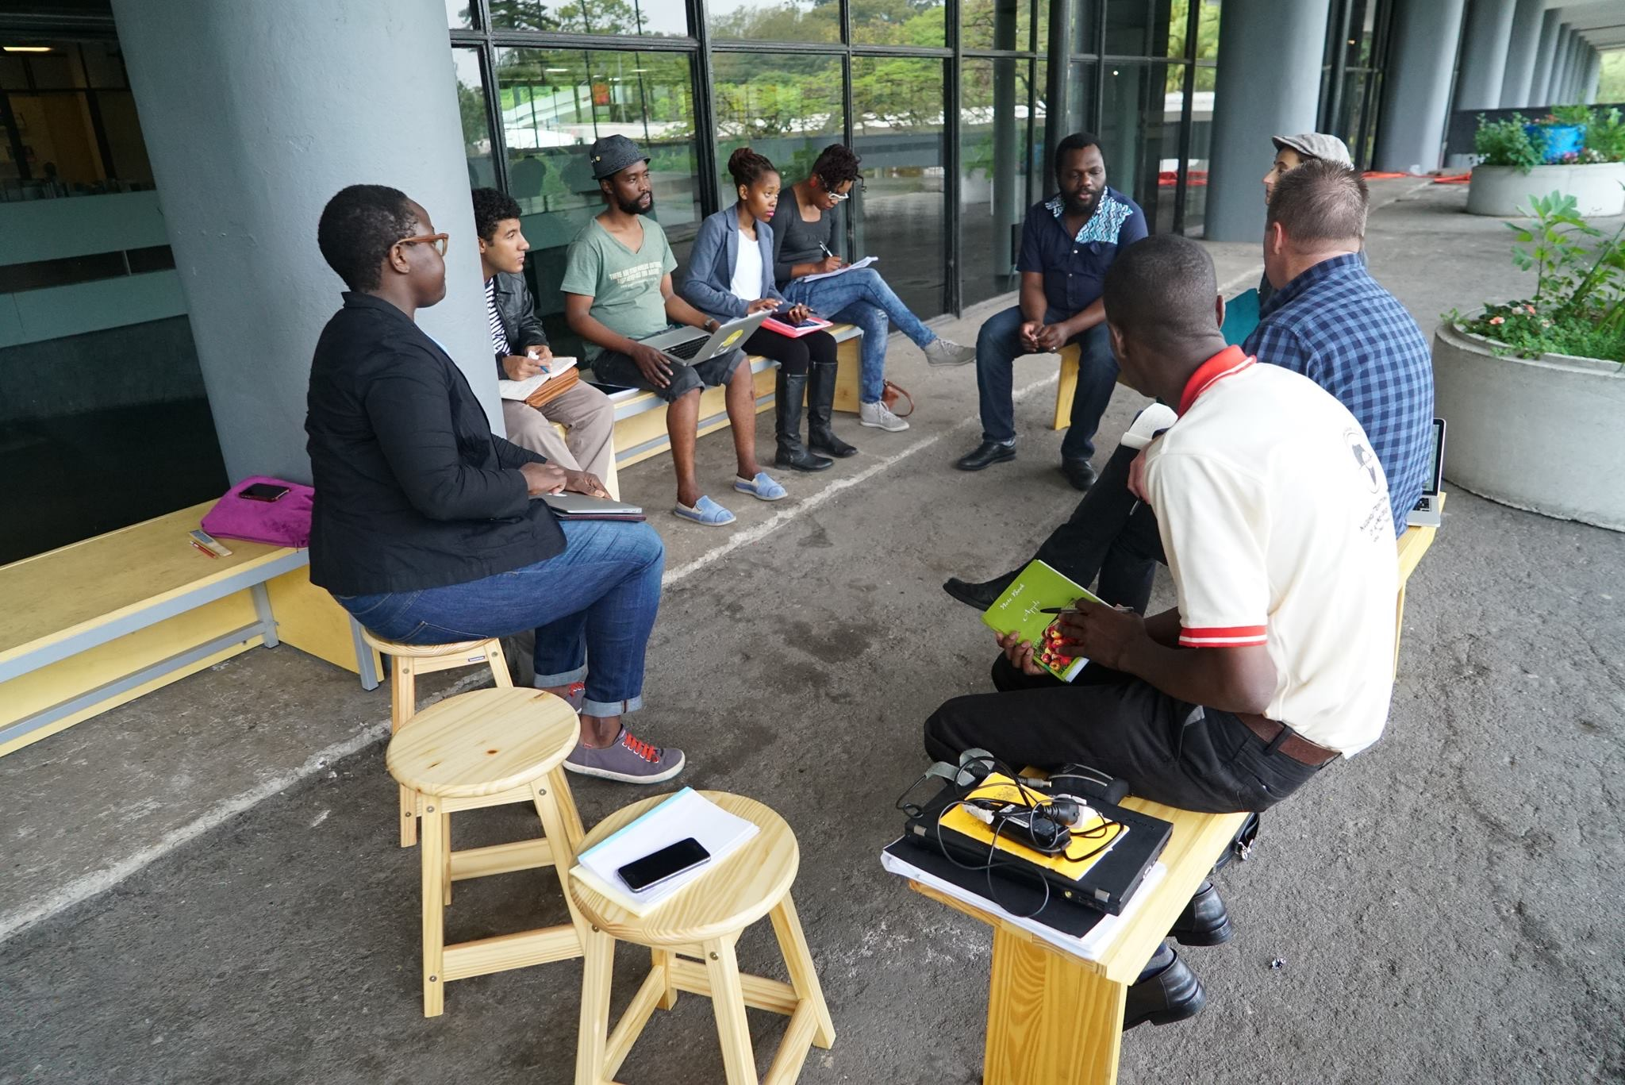
Joint meeting of the Intertwining Hi/stories and Africa Clusters hosted by the 32nd Bienal de São Paulo – INCERTEZA VIVA, São Paolo, Brazil
Photo: Christian Nyampeta, 2016

http://colivre.net/another-roadmap/news/activities-between-october-24-and-29-at-the-space-cozinha-in-the-bienal-pavilion-sao-paulo
http://colivre.net/africa-cluster/blog/the-visit-a-memoir-of-africa-cluster-colloquium-2-sao-paolo-october-2015 (VIDEO FORTHCOMING)

April 2017
2nd Colloquium of the Another Roadmap Africa Cluster hosted by Keleketla! Library and the Wits School of Art, Johannesburg, South Africa

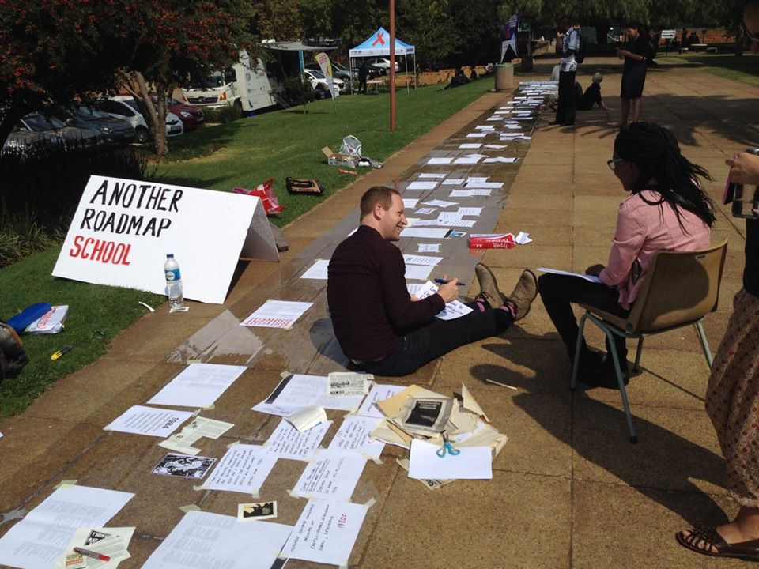
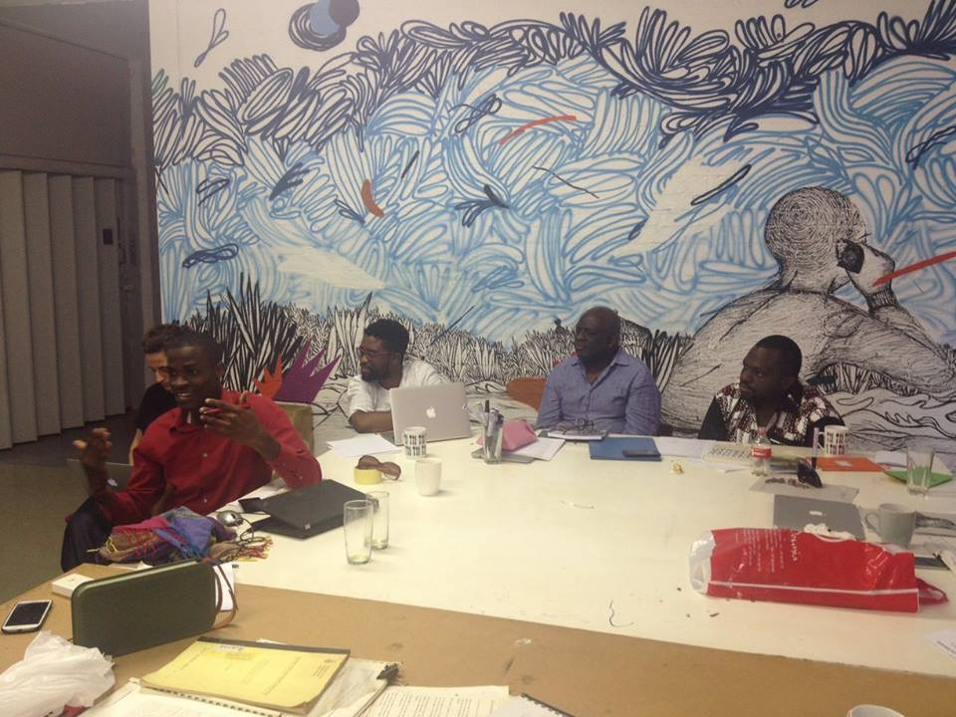

Photos by David Andrew, 2017

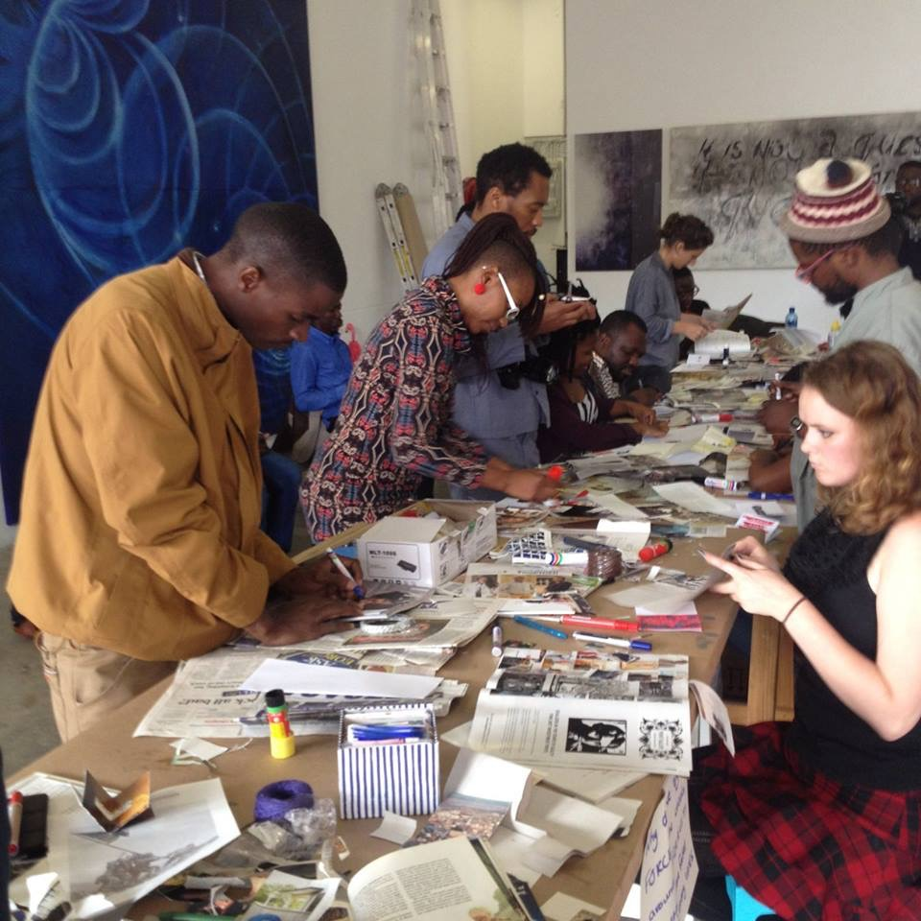
http://colivre.net/africa-cluster/blog/africa-cluster-colloquium-2-public-event-day-1-and-2
http://colivre.net/africa-cluster/blog/africa-cluster-colloquium-2-visiting-expert
http://colivre.net/africa-cluster/blog/pro-helvetia-2017-report-arac-sadc-members
http://colivre.net/africa-cluster/blog/people-who-think-together-dance-together-africa-cluster-colloquium-2
http://colivre.net/africa-cluster/blog/moments-from-africa-cluster-colloquium-3-johannesburg-april-2017 (VIDEO)

October 2017 (forthcoming)
Intertwining Hi/stories Festival, Vienna, AT

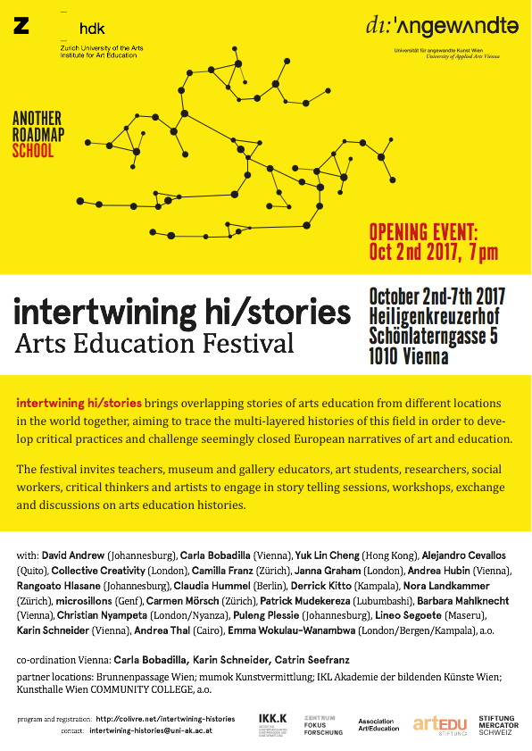

http://colivre.net/intertwining-histories/blog/intertwining-histories-arts-education-festival
http://colivre.net/intertwining-histories/blog/schedule-for-the-festival-save-the-date

